SCENARIO 1 – USER-BASED COLLABORATIVE FILTERING
Problem Statement
Recommend movies to users based on similar users' preferences.
Dataset (Kaggle – Public)
MovieLens Dataset Dataset Link: https://www.kaggle.com/datasets/grouplens/movielens-100k
(You can pick any dataset if required)
Target Variable: Recommended movies for a given user
Input Feature:
• User ID
• Movie ID
• Ratings
• Timestamp
CODE:
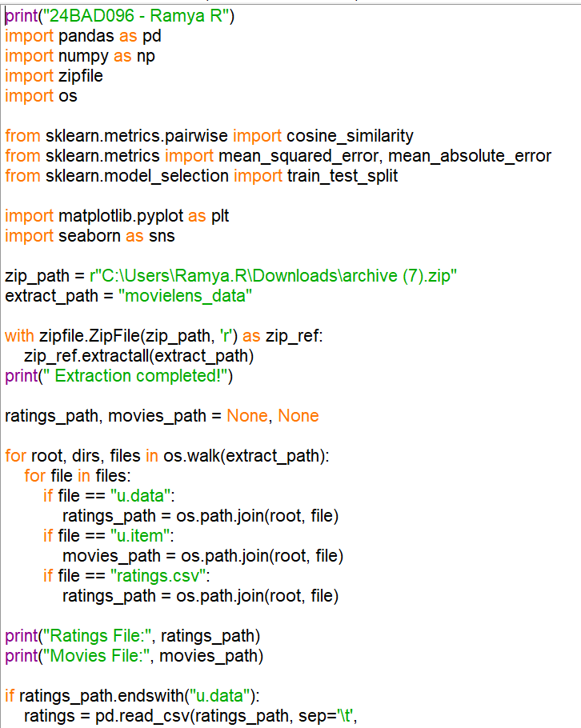P
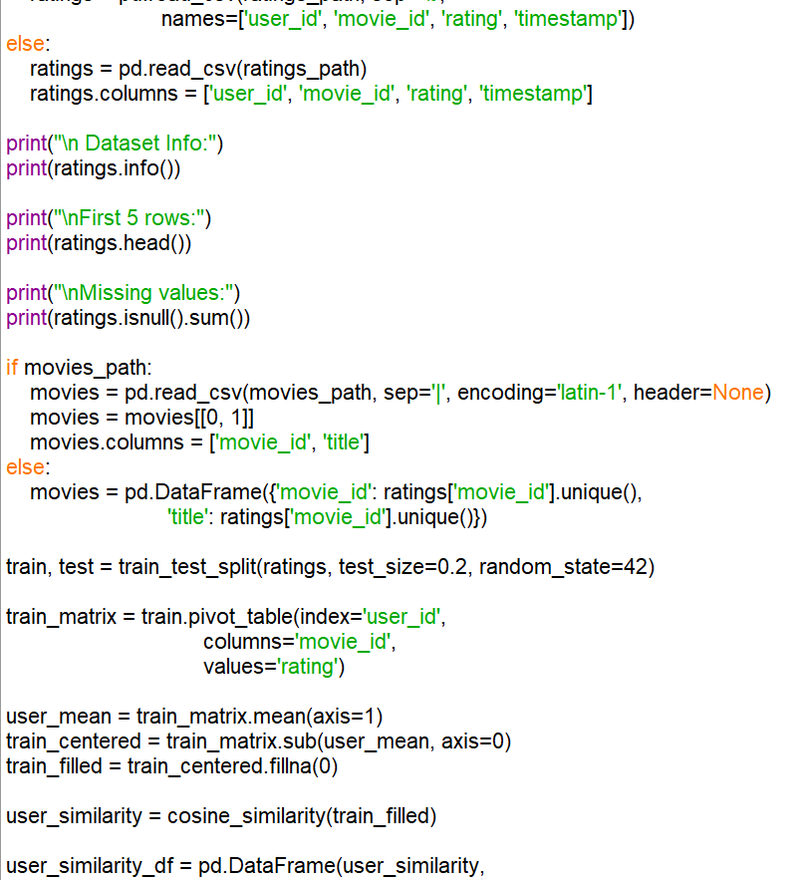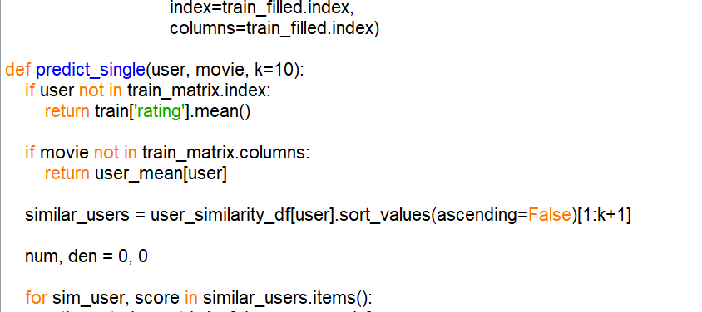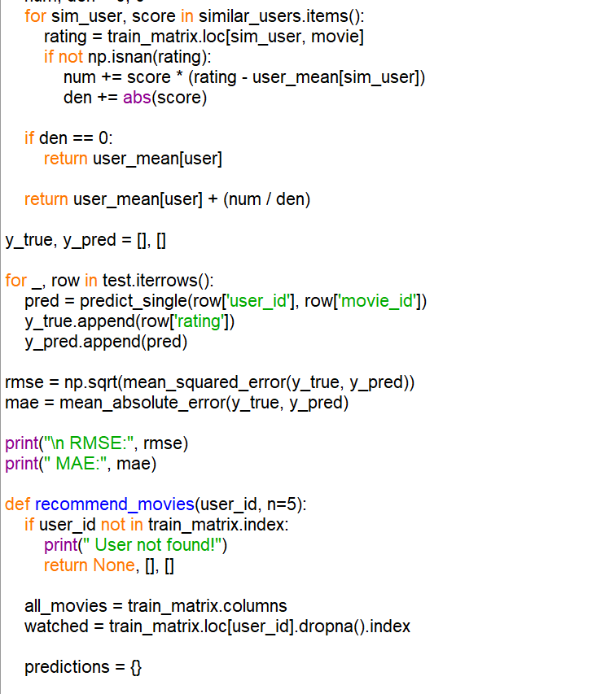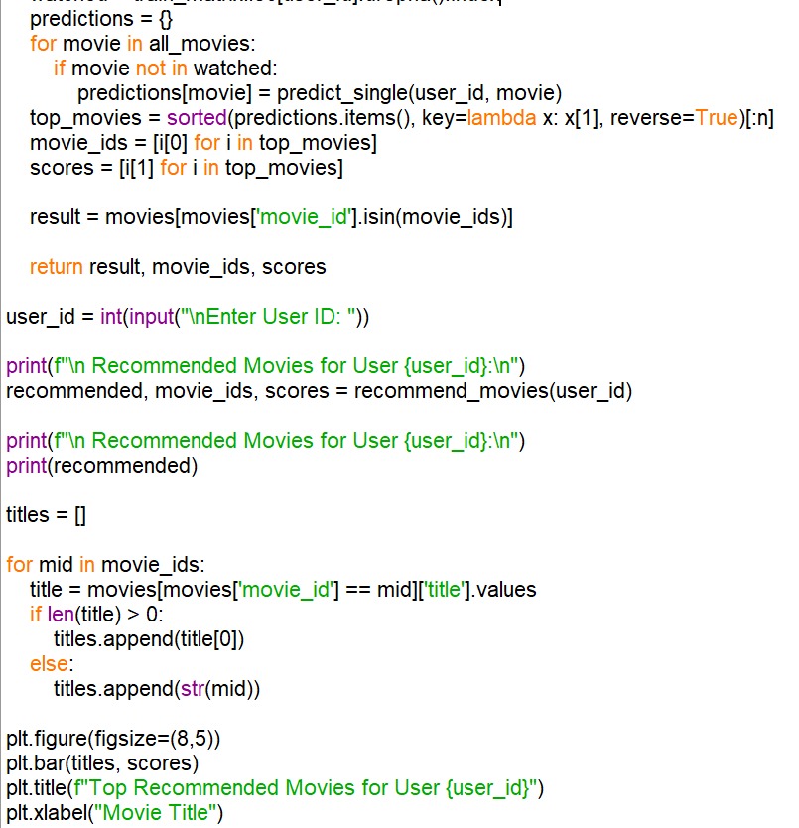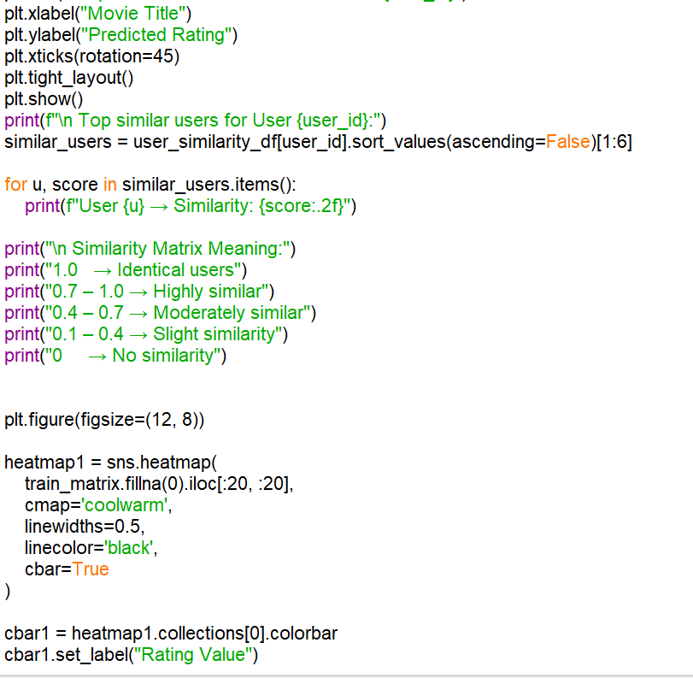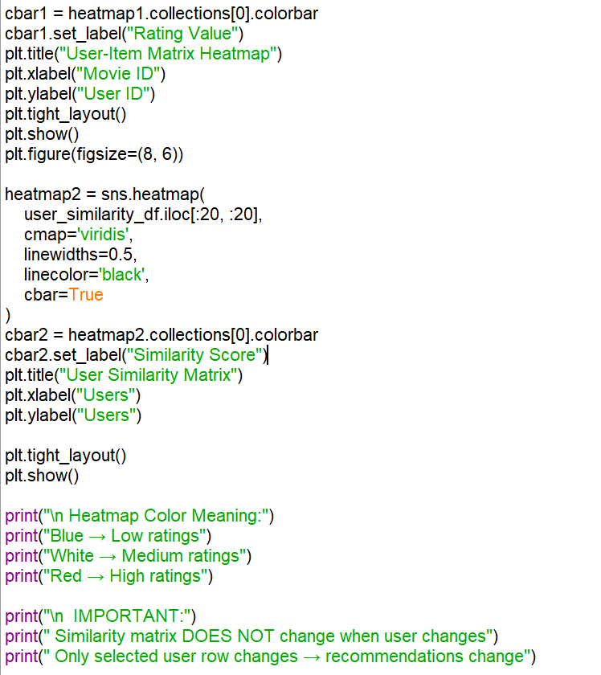

OUTPUT:
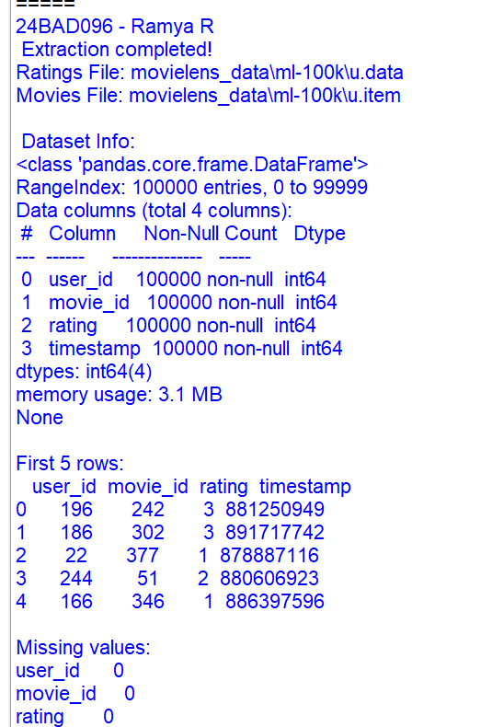
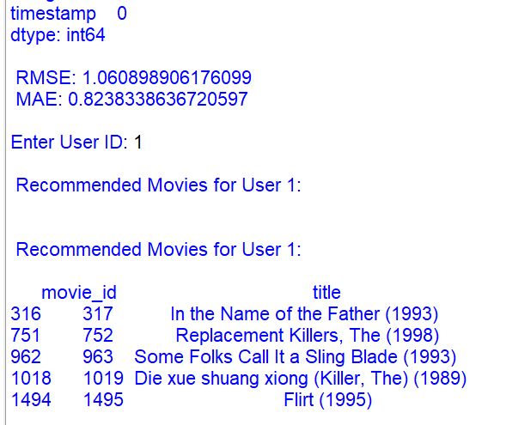

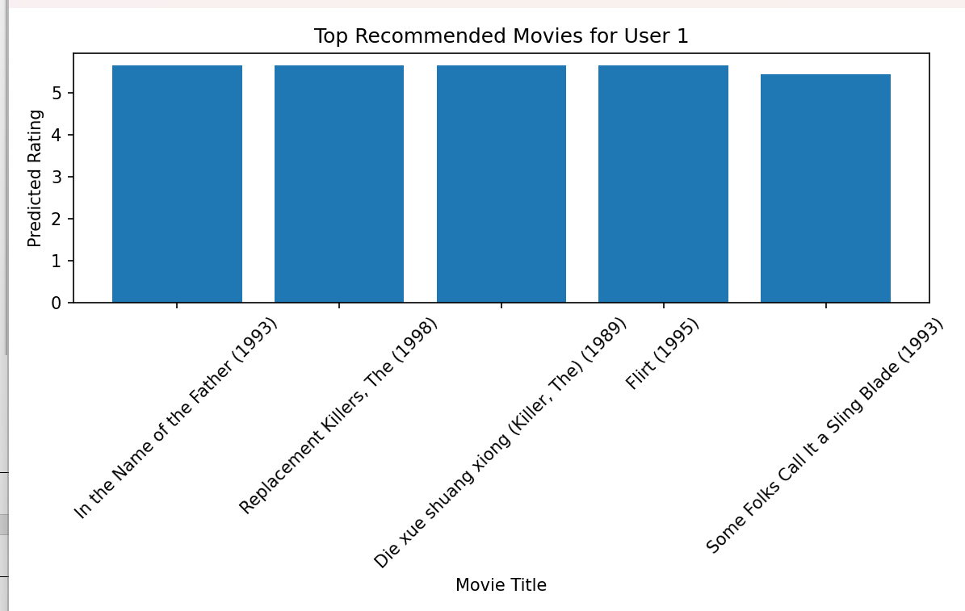
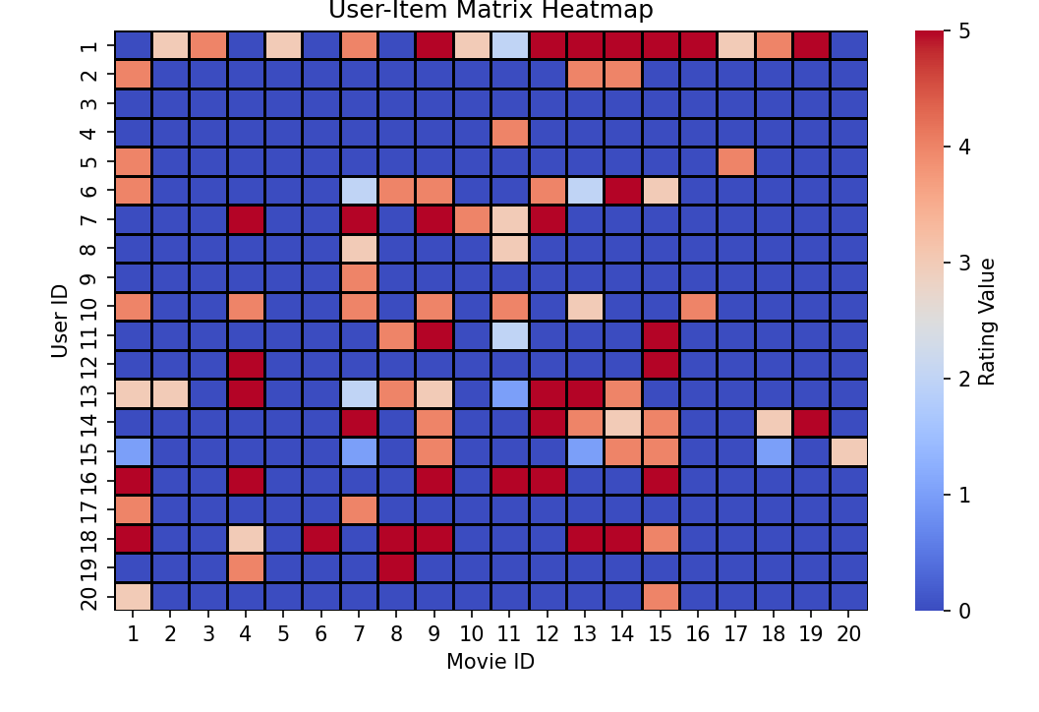

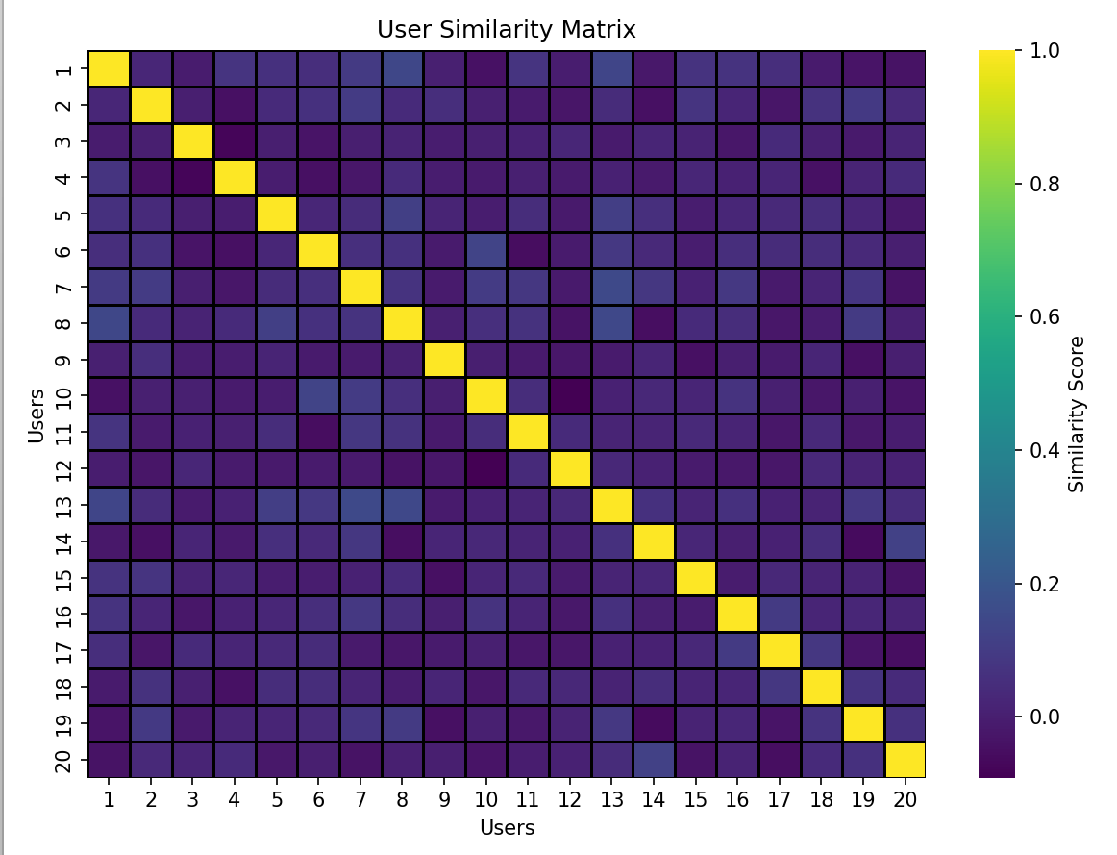

SCENARIO 2 – ITEM-BASED COLLABORATIVE FILTERING
Problem Statement
Recommend similar items (movies/products) based on user ratings.
Dataset (Same / Alternative Dataset)
MovieLens Dataset / Amazon Product Dataset
Target Variable: Recommended items similar to a given item
Input Features
• Item ID
• User ratings
• User interactions

CODE:
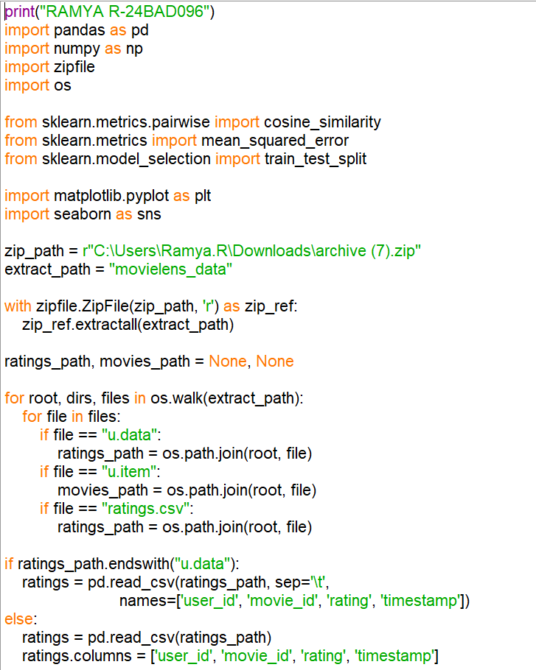
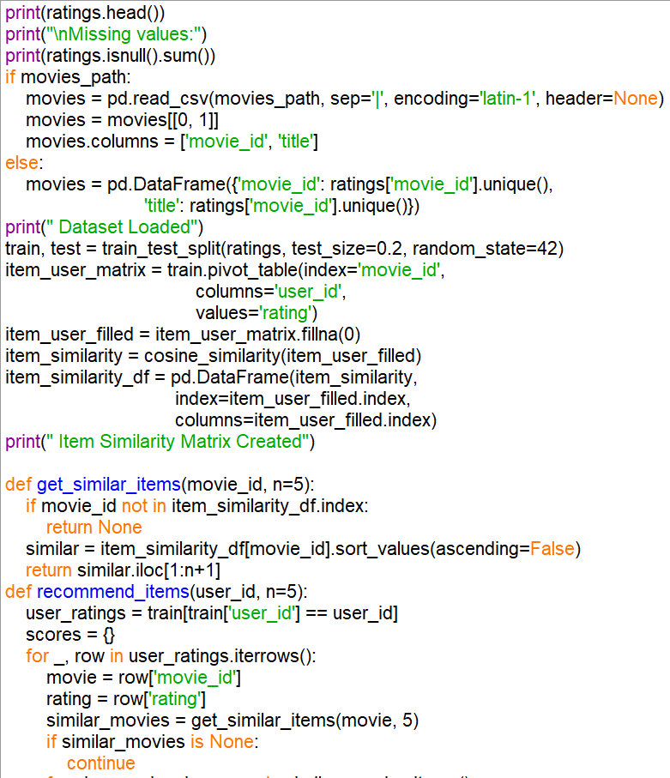
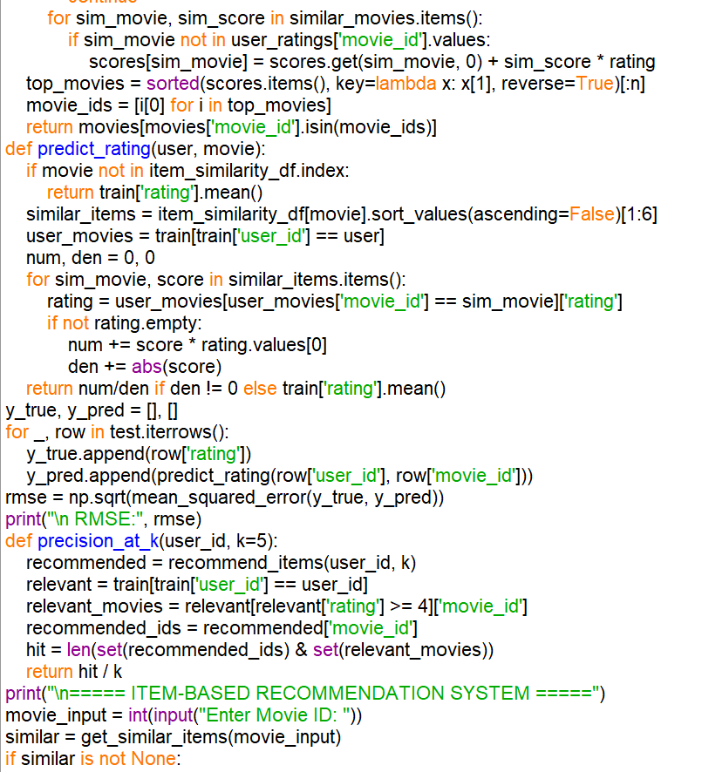
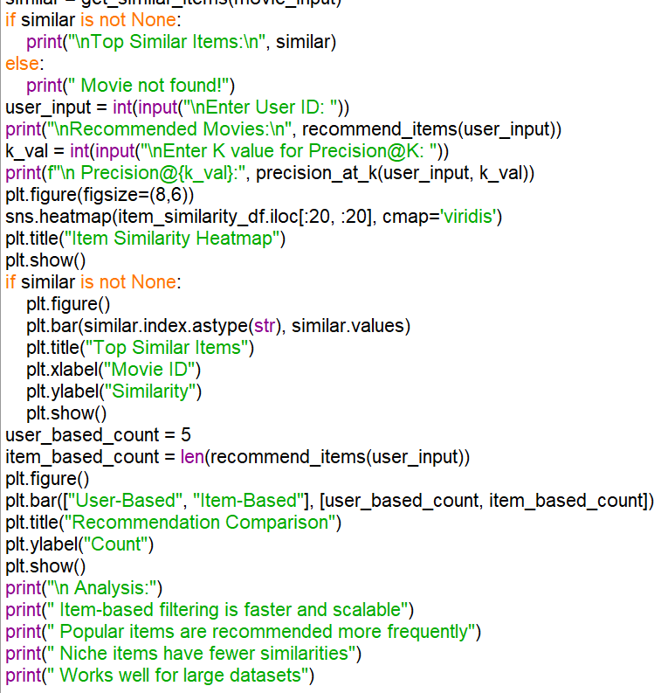

OUTPUT:
